|  |  |  |  |  |  |  |  |
| --- | --- | --- | --- | --- | --- | --- | --- |
| Capstone Project Step-by-Step Solution | | | | | |  | Task |
| 3 |
|  | | | | |  |  |  |
|  |  |  |  |  | | |
|  | | | | |  |  |

Import an **Strawberry** **sFone** item into the Service Catalog to be requested and develop a Flow Designer Flow to support and complete the fulfillment process.

**Refer to** Module 4: Configure Self-Service

1. Import a Service Catalog Item

Use the Update Set process to bring in an already developed Strawberry Service Catalog item.

1. Navigate to **All > System Update Sets > Retrieved Update Sets**.
2. Under **Related Links**, select **Import Update Set from XML**.
3. Choose the file (**cd_sfone_catalog_item.xml**) and click **Upload**.

The *Cloud Dimensions sFone* update set XML file now appears in the Retrieved Update Sets list with a State of Loaded.

1. Open the **Strawberry** **sFone** record.
2. Click **Preview Update Set**.
3. **Close** the *Update Set Preview* dialog box.
4. Click **Commit Update Set**.
5. **Close** the *Update Set Commit* dialog box.
6. Return to the **Retrieved Update Sets** list and confirm the *State* of the *Strawberry sFone* update set is **Committed**.
7. Create a New Flow Designer Flow

To support the fulfillment of incoming Service Catalog requests for the Strawberry sFone item, create a new Flow Designer Flow.

1. Navigate to **All > Process Automation > Flow Designer**.
2. Click the **New** button.

1. Select **Flow**.

1. Populate the form with the following information:

Name: **Strawberry Workflow**  
Run As: **System User**

1. Click **Submit**.
2. Optional: Click Take tour to get an overview of Flow Designer.

Alternative: The tours may also be accessed by using the Toggle the Help panel icon.

1. Verify the **Flow Designer** interface appears.

1. Define a Trigger to Activate the Flow
2. Click the plus **(+)** icon to the left of **Add a Trigger**.

1. Select **Service Catalog** from the Application section.

1. Click **Done** to complete the Service Catalog trigger.
2. Add an Action to Ask for Approval of the Requested Item
3. Under the **ACTIONS** section, click the plus **(+)** icon to the left of **Add an Action, Flow Logic, or Subflow**.



1. Click **Action**.

1. Select the **Ask for Approval** default action type within the **ServiceNow Core Installed Spoke**.

1. Choose the **Requested Item Record** to update:
2. In the **Data** Panel, expand the **Trigger - Service Catalog** section.
3. Drag the **Requested Item Record** pill from the Data Panel to the **Record** field.
4. Release your mouse to “drop” the pill into the **Record** field.

**Note:** This will automatically populate the Table field with **Requested Item** [sc_req_item].

1. Verify the **Table, Approval Field and Journal Fields** are auto-filled based on the Requested Item record.

1. In the Rules section, open the **Choose approval rule** dropdown.

1. Select **Anyone approves**.
2. Click the **Data Pill Picker** icon to the right of the **Anyone approves** field.

1. Clicking the Data Pill Picker icon will open a search box where you can dot-walk to select the **Manager of the requester** for the requested item.
2. Click **Trigger - Service Catalog**, then click **Requested Item Record**. Click the **right arrow** to navigate to the list of fields on the **Requested Item Record**.

1. Scroll down and locate the **Requested for** field.

1. Click the **right arrow** icon to navigate to the list of fields on the **Requested for Record,** thenselect **Manager**.

User

1. Hover on the Trigger Pill to ensure it displays **Trigger-Service Catalog -> Requested Item Record -> Requested for -> Manager**.

1. Click **Done**.
2. Click **Save**.



1. Add a Wait For Condition

Now that the approval has been requested, the next step is to wait for an approval (or rejection) from the manager. To accomplish this, we add a Wait For Condition action.

1. Click the plus **(+)** icon to the left of **Add an Action, Flow Logic, or Subflow**.
2. Click **Action**.

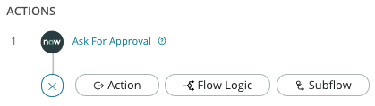

1. Select the **Wait for Condition** in the **ServiceNow Core** Installed Spoke.

1. Drag and drop the **Trigger > Requested Item Record** to the **Record** field. This will automatically populate the **Table** field with *Requested Item [sc_req_item]*.

1. Set the Condition to **Approval | is | Approved**.

1. Select **OR** and add the condition **Approval | is | Rejected**.

1. Click **Done**.
2. Add Flow Logic – If

If the requested approval is Approved, the tasks for fulfilling the catalog item request can be created. If the requested approval is Rejected, an email notification can be created to inform the requester.

1. Click the plus **(+)** icon to the left of **Add an Action, Flow Logic, or Subflow**.

1. Click **Flow Logic**,then select **If**.

1. Type **Requested Item Approved**in the Condition box.
2. Drag and drop the **Approval State** field from **1 – Ask For Approvals** to **Condition 1**.

1. Complete the Condition 1 criteria by selecting **Approved** from the list of Approval states.

1. Click **Done**.
2. Add a Create Catalog Task Action – Order an Item
3. Ensure you are within the If Requested Item Approved step of the flow, then click **Action**.

1. Select the **Create Catalog Task** action within **ServiceNow Core > Service Catalog**.

1. Drag and drop the **Requested Item Record** pill from section **Trigger – Service Catalog** to the **Requested Item [Requested Item]** field.
2. Type **Order the Strawberry sFone** in the **Short Description** field.
3. Add field values in the **Fields** section by clicking on **+Add field value**.

1. Populate the form with the following information by clicking **+ Add field value** for each field identified below:

**Assignment Group | Procurement**

**State | Open**

**Short Description | Order Strawberry sFone**

1. Notice the **Wait** field is checked by default. This pauses the flow until the task completes and is no longer active (e.g., when the task is marked Closed Complete).
2. Click **Done**.
3. Click **Save**.
4. Add a Create Catalog Task Action – Configure an Item
5. Click the plus **(+)** icon below the **If Requested Item Approved** step.

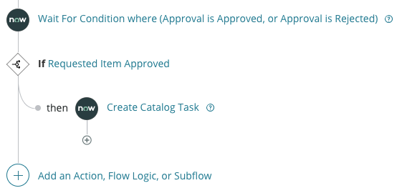

1. Click **Action**.

1. Select the **Create Catalog Task** **action** within **ServiceNow Core > Service Catalog**.

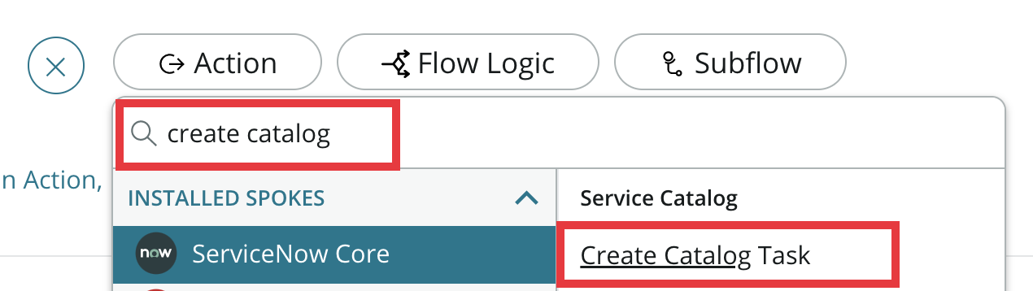

1. Drag and drop the **Requested Item Record** pill from section **Trigger – Service Catalog** to the **Requested Item [Requested Item]** field.
2. Type **Configure the Strawberry sFone** in the **Short Description** field.
3. Add field values in the **Fields** section by clicking on **+Add field value**.
4. Populate the form with the following information:

**Assignment Group | Software**

**State | Open**

1. Click **Done**, then click **Save**.
2. Add a Create Catalog Task Action – Deliver Item
3. Click the plus **(+)** icon below the second **Create Catalog Task** action, then click **Action**.

1. Select the **Create Catalog Task** action within **ServiceNow Core > Service Catalog**.

1. Drag and drop the **Requested Item Record** pill from section **Trigger – Service Catalog** to the **Requested Item [Requested Item]** field.
2. Type **Deliver Strawberry sFone** in the **Short Description** field.
3. Populate the fields with the following information by clicking **+Add field value** for each field below:

**Assignment Group | Service Desk**

**State | Open**

**Description | Deliver item to requester or requester’s manager**

1. Click **Done**.
2. Click **Save**.
3. Locate the Annotation icon to the right of each Task action.

1. For each task action, **add an annotation** to make it easy to identify each task.

1. Add Flow Logic – Else If
2. Click the plus **(+)** icon to the left of **Add an Action, Flow Logic, or Subflow**.

1. Click **Flow Logic** and then select **Else If**.

**Note:** If the Else If logic choice is not available, you may need to clear your cache or use another browser window.

1. Type the following for the Condition Label: **Requested Item Rejected**.
2. Drag and drop the **Approval State** field from **1 – Ask For Approvals** to **Condition 1**.

1. Select **Rejected** from the list of Approval states.
2. Click **Done**.
3. Click **Action** within the **Else IF** logic.

1. Select **Send Email** within **ServiceNow Core > Default**.

Now we will populate the **Send Email** fields.

* + 1. This will require dot-walking.

1. In the **To** field, click the **data pill picker**.

1. Navigate the following path:

Trigger - Service Catalog->Requested Item Record->Requested for->Email

1. On **Subject,** type: **Your request for a Strawberry sFone has been rejected**.
2. Click **Done**.

Rather than having the Else If branch stop with the Send Email action, let’s add logic to end the flow once the email has been sent.

1. Click the plus **(+)** icon below the **Send Email** action and click **Flow Logic**.

1. Click **Flow Logic** and select **End Flow**.

1. Click **Save**.
2. Verify your flow is as shown below.

1. Create an Update Record task to Close the Requested Item Record

Once the fulfillment tasks have been completed for the approved item, the State of the Requested Item should be updated to Closed Complete.

1. Click the plus **(+)** icon to the left of **Add an Action, Flow Logic, or Subflow**.

1. Click **Action**.
2. Under **ServiceNow Core > Default**, locate and select the **Update Record** action type.

1. Drag and drop the **Trigger > Requested Item Record** to the **Record** field. This will automatically populate the **Table** field with *Requested Item [sc_req_item].*

1. Click **+Add Field Value** and set **State** to **Closed Complete**.

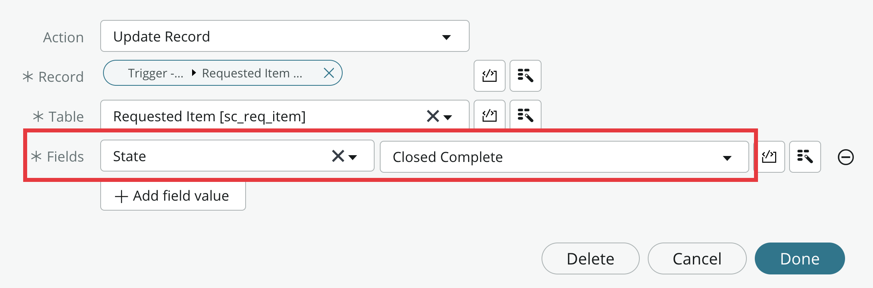

1. Click **Done**, then click **Save**.
2. Click the **View** toggle on the workflow header to change the flow layout.



1. Click the View toggle again, to return to the default flow layout.
2. Activate and associate flow to Service Catalog Item
3. Click the **Activate** button.



1. A message will appear confirming you would like to activate the flow – click **Activate**.
2. Return to the main ServiceNow window and navigate to **All >** **Service Catalog > Catalog Definitions > Maintain Items**.
3. Locate and open the **Strawberry** **sFone** item record.

1. Scroll down and select the **Process Engine** tab.
2. Type **Strawberry Workflow** into the **Flow** field.

1. Click **Update** to save the Strawberry item record and return to your previous screen.

LAB VERIFICATION

1. Test the Flow – Order a Strawberry sFone

To test the Flow, impersonate David Loo and order the sFone. Then impersonate David’s manager to approve the request.

1. Navigate to System Properties by typing ***sys_properties.list*** in the Filter Navigator.
2. Locate the **com.snc.process_flow.reporting.level** and set the Value to **ON**. You can do this by opening the record and typing the value ON, or you can edit directly inline by double-clicking in the field.

1. Impersonate **David Loo.**

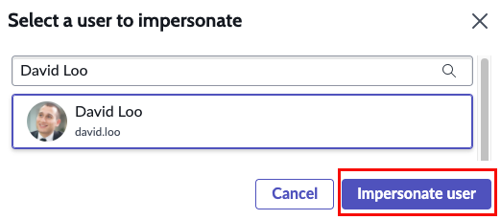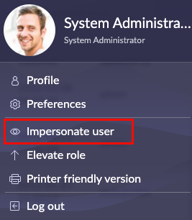

1. Navigate to **All > Self-Service > Service Catalog**.

1. Click the **Mobiles** category.
2. Locate and select the **Strawberry** **sFone** item.
3. Confirm the *title*, *description*, and *picture* are displayed.
4. Open the **sFone Prototype** item.
5. Click **Order Now**.

* + 1. You should see a confirmation message that your request has been submitted.

1. Impersonate **Bud Richman** (David’s manager).
2. Navigate to **All > Service Desk > My Approvals**.
3. Open the approval request by clicking the **Requested** link.

1. Click **Approve**.

1. **End impersonation**.
2. Complete the Tasks to Fulfill the Request

As the System Administrator, you will test the flow logic by completing the catalog tasks rather than impersonating users in the fulfillment groups.

1. Navigate to **All > Service Catalog > Open Records > Tasks**.
2. Open the task with the short description, **Order the Strawberry sFone**.
3. Click **Close Task**.
4. From the List Controls Menu, select **Refresh List** (or refresh your browser).
5. Open the task with the short description, **Configure the Strawberry sFone**.
6. Click **Close Task**.
7. Refresh the list (If the next task does not appear, refresh the list again).
8. Open the task with the short description, **Deliver Strawberry sFone**.
9. Click **Close Task**.
10. Review Flow Execution
11. Navigate to **All > Process Automation > Flow Designer**.
12. Locate, then select the **Strawberry Workflow**.
13. Open the **Strawberry Workflow** execution.

1. Open the **Strawberry Worflow** and review the status of the workflow (**Completed**) and the State of each step. Is it what you expected? If not, troubleshoot and work through the Lab Validation steps again.

